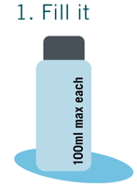 |  | 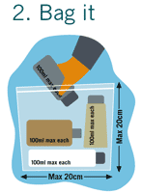 |  | 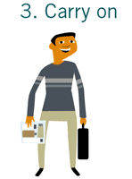
 | Liquids, Aerosols and Gels in your hand luggage must be in containers of maximum 100ml each. |  | Store them in a transparent, resealable bag. Total bag capacity must be maximum one litre.  Only one bag per passenger will be allowed. |  | Be prepared before you check-in by having your bag out at the security check.  Enjoy your travel experience.
 |  | 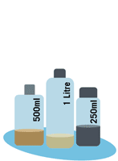 |  | 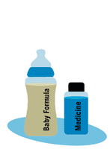
 | We do not want to confiscate your belongings so if they do not comply with the new rules, pack them in your check-in luggage. |  | No containers over 100ml in your hand luggage, even if they are partially filled. |  | Baby formula and food as well as medication carried on-board need not be in your LAGs bag but remember to show them to Security. If carrying medication you may need to produce your prescription.

Exceptions
There are some exceptions regarding. In each of these instances, the capacity does not have to be restricted to 100ml, and the containers do not have to be placed in your transparent, resealable plastic bag.
Medication
You may carry medication in your hand luggage or check it in. If you carry it in your hand luggage, it will be inspected by security staff to ensure prohibited items are not being concealed. You may be asked for a prescription. You may also be asked to taste your medication in the presence of security personnel.
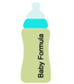 |  | Baby food  Baby food including formula and milk is exempted provided you are travelling WITH your baby. You may be asked to taste your formula/milk in the presence of security personnel.
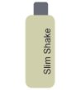 |  | Special diet food  Liquids that form part of special diets may be carried in your hand luggage but you may be asked to prove the necessity and authenticity of the liquids to security personnel. You may be asked to taste these items in the presence of security personnel.
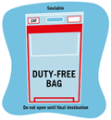 |  | Duty-free purchases  Duty-free shoppers can rest assured that they can still buy duty-free items at the airport but must be mindful of the fact that the transfer and termination regulations pertaining to duty-free LAGs purchases differ globally. Passengers are thus encouraged to contact the airline they will be travelling with well in advance to establish the latest duty-free LAGs regulations in effect in the country they will be transferring through, and ultimately terminating their journey in. ACSA continues to work closely with the South African Civil Aviation Authority in this regard whilst duty-free sales staff remain ready in-store to assist passengers. Duty-free shoppers are reminded that their LAGs purchases must be kept sealed in the special plastic bag, given at the point of purchase, until they reach their final destination.

